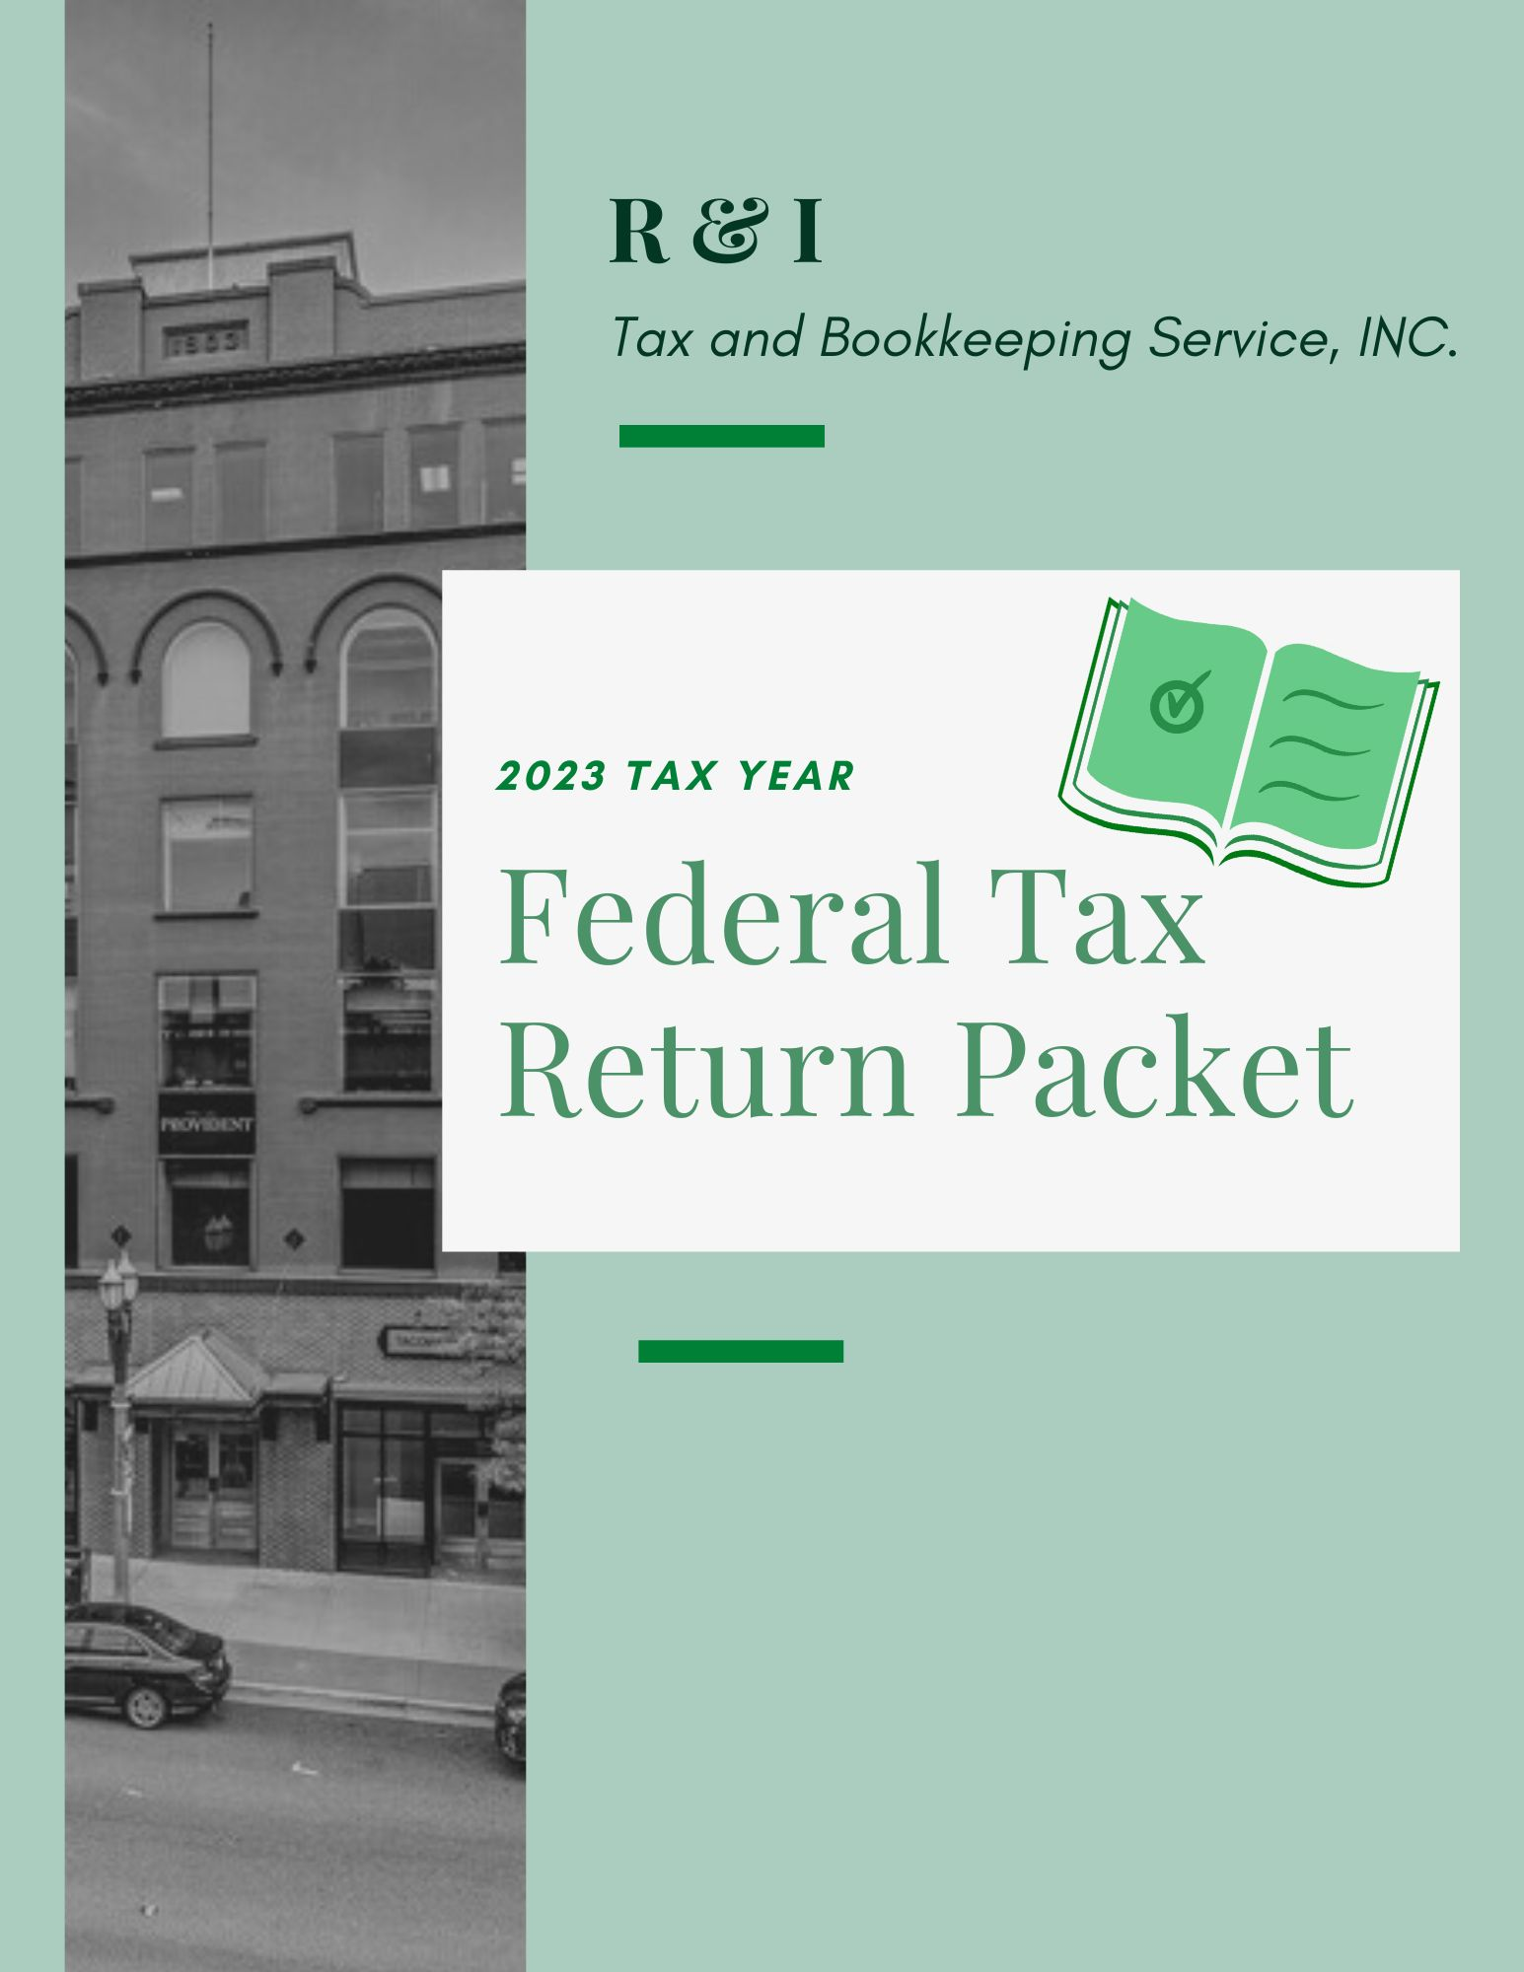
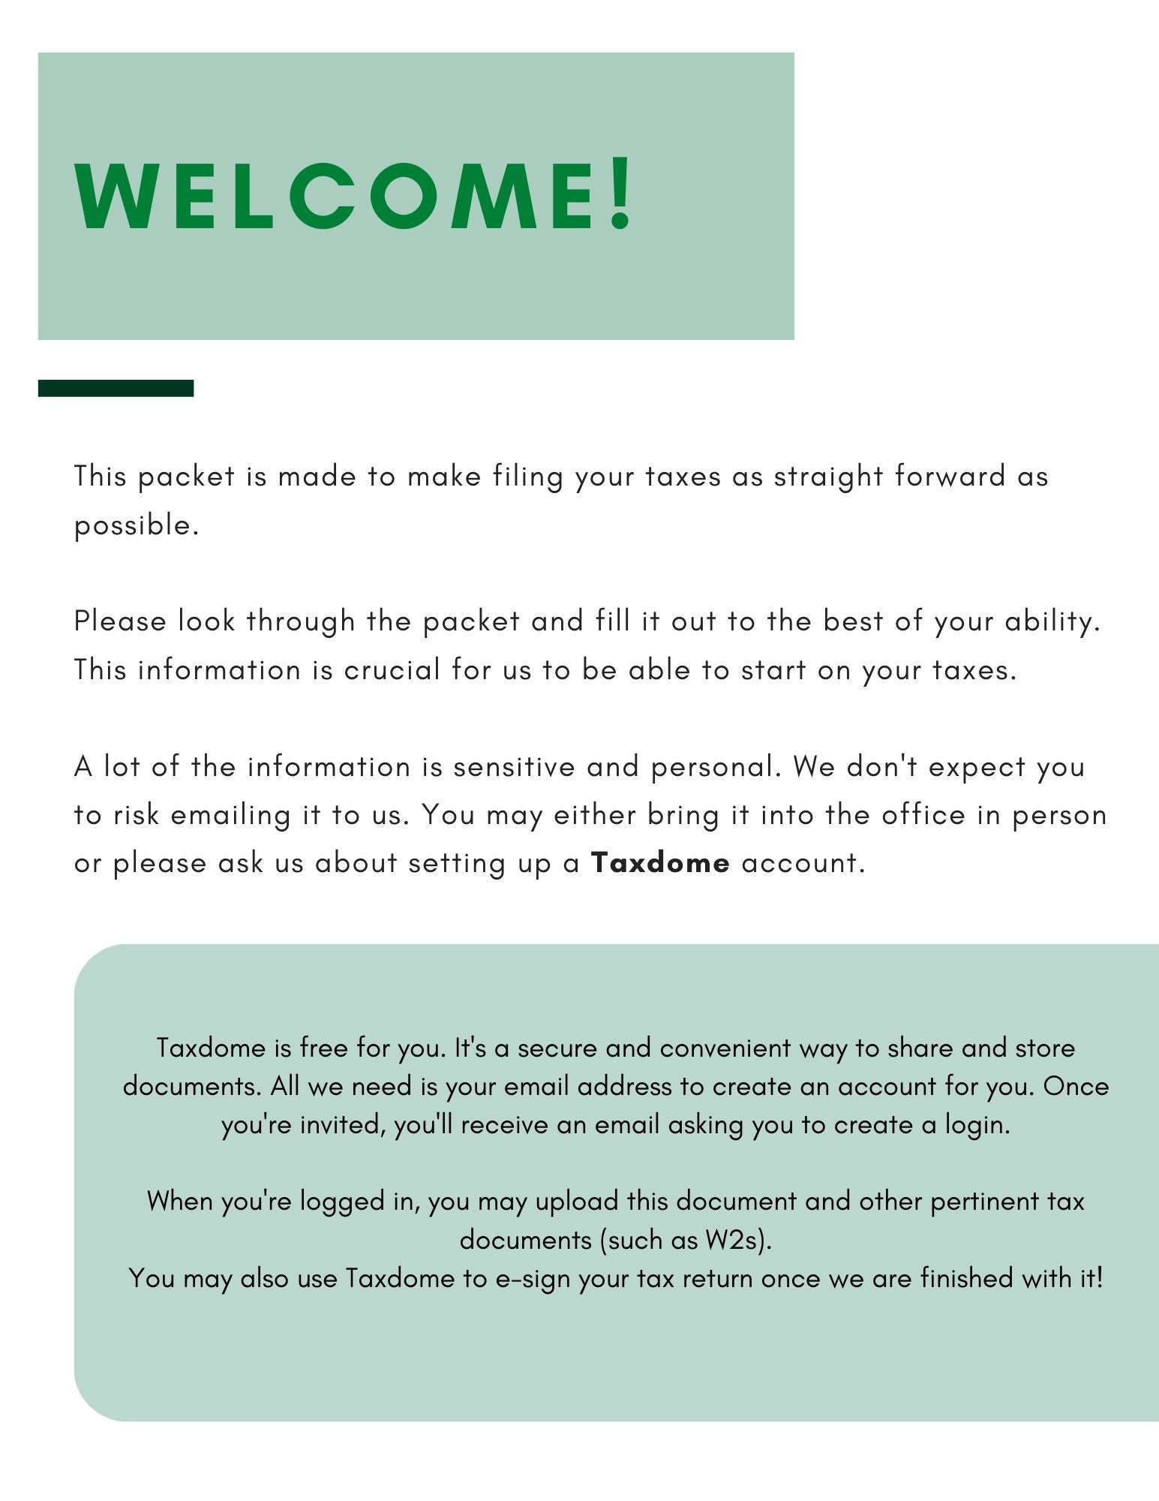
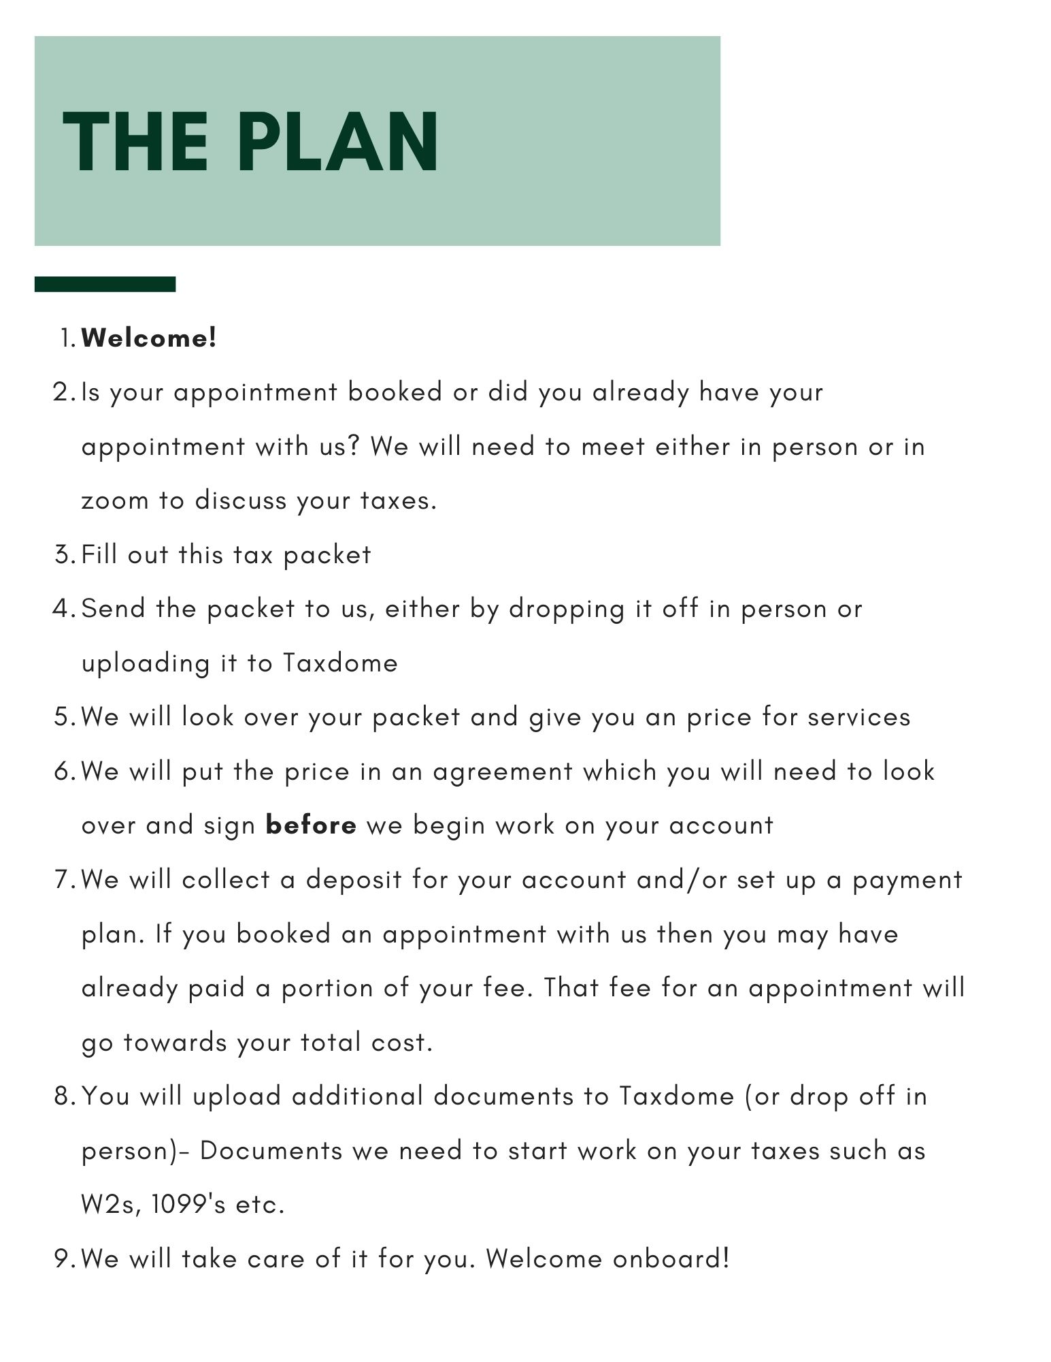

tax Preperation Service Agreement
This contract is between R & I Tax & Bookkeeping Service, Inc. (the "Business") with a mailing address of 917 Pacific Ave, suites 411, 412, 414, 416 Tacoma, WA 98402
AND
The business entity of ____________________________________("client")
with a mailing address of ________________________________________
Whereas the Client and Bookkeeper/Accountant ("Parties") agree to the following terms and conditions for the bookkeeper/accountant's services, as an independent contractor, in exchange for fees.
SELECT ALL THAT APPLY
Tax Preparation Package- Essentials _____________
Tax Preparation Package- Premium _____________
Tax Sole Proprietor Package _____________
Tax Partnership Package _____________
Tax LLC Package _____________
Tax Non-profit Package _____________
Tax Corporation Package _____________
Tax S-Corporation Package _____________
The selections shall be referred to as the "Services". The Bookkeeper/Accountant shall conduct the Services within the specifications and guidelines set by the Client. The Bookkeeper/Accountant shall, always, observe and comply with generally accepted bookkeeping and accounting practices and standards while complying with all Federal and State laws, regulations and procedures when completing their Services in accordance with this Agreement.

tax Preperation Service Agreement terms
Invoices
The Business will invoice the Client after completion of milestone(s) or the Project, unless otherwise noted in the Payment schedule. The Client agrees to pay invoice(s) by the due date(s) specified. Unpaid or overdue invoices may result in suspension or termination of the Project.
Payment methods
Payment will be made to the Business via cash, check, an approved payment card, or by any other payment method determined by the Business.
Refund(s)
No returns, exchanges or refunds are permitted. The client is free to terminate services at any time, but their deposits and fees paid up until that date are non-refundable and the client is responsible for paying for all work and costs incurred up until that date.
Licensing
The Business promises that it holds all licenses necessary to perform the work, that such licenses are valid and effective as of the date any work is performed or services provided, and that all work performed or services provided will be done in compliance with all applicable federal, state, or local laws and regulations.
Authority to sign
Each party has the authority to enter into this Contract and to perform all of its obligations under this Contract.
Termination of contract
The Contract ends on completion of services unless one of the parties ends the contract before that time. If one of the parties chooses to end the Contract prior to Project completion, the Client is responsible for paying for all work and costs incurred up until that date.
Modifications
The Client and the Business must agree to any changes to this contract in writing.

tax Preperation Service Agreement - Payment Schedule
The Client paid a deposit of $________________ on __________________(date)
The Client will pay the Business the remaining fee balance of____________ ($ amount total). Due in full on completion of services.

This contract may be signed electronically or in hard copy. If signed in hard copy, it must be returned to the Business for valid record. Electronic signatures count as original for all purposes.
By typing their names as signatures below, both parties agree to the terms and provisions of this agreement.

_______________________________ _______________ __________________
Signature Title Date

Linda Yarbrough President
_______________________________ _______________ __________________
Signature Title Date

PERSONAL INFORMATION
Taxpayer Full Name: ____________________________________
Address: ______________________________________________
Phone Number: _________________________________________
Email: ________________________________________________
Occupation: ___________________________________________
Social Security Number: __________ ______ ___________
Date of Birth: _______/________/____________
Do you wish $3 to go to the presidential election campaign? (tax amount not affected)
YES NO
FILING STATUS:
SINGLE MARRIED HEAD OF HOUSEHOLD WIDOW

Spouse’s Full Name: ____________________________________
Address: ______________________________________________
Phone Number: _________________________________________
Email: ________________________________________________
Occupation: ___________________________________________
Social Security Number: __________ ______ ___________
Date of Birth: _______/________/____________

If you would like your tax refund (if any) deposited directly into your bank:
Accounting type (checking or savings)
Account number:
Bank routing number:
VIRTUAL CURRENCY:
At any time during _________ (year), did you receive, sell, send, exchange, or otherwise dispose of any financial interesting any virtual currency?
YES NO
ADVANCE CHILD TAX CREDIT PAYMENT:
Enter the aggregate amount of advance child tax credit payments you (and your spouse if filing jointly) received for __________ (year).
The amount to include on this line are found on your IRS Letter(s) 6419

Dependent INFORMATION
First Name: ___________________________________________________________
Middle Initial: ________
Last Name: __________________________________________________
Income over 2,200: YES NO
Social Security Number: __________ _______ ___________
Date of Birth: ________/________/__________
Relationship: __________________________
Months Living in Home in 2022: __________________
First Name: ___________________________________________________________
Middle Initial: ________
Last Name: __________________________________________________
Income over 2,200: YES NO
Social Security Number: __________ _______ ___________
Date of Birth: ________/________/__________
Relationship: __________________________
Months Living in Home in 2022: __________________
First Name: ___________________________________________________________
Middle Initial: ________
Last Name: __________________________________________________
Income over 2,200: YES NO
Social Security Number: __________ _______ ___________
Date of Birth: ________/________/__________
Relationship: __________________________
Months Living in Home in 2022: _________________

income

IF YOU HAVE RECEIVED ANY OF THE FORMS BELOW, WE WILL NEED A COPY OF EACH.
- W-2 (or other wage income)
- 1099-G (state or local income tax refunds)
- 1099-INT (or other interest and dividend income)
- 1099-R, SSA-1099 (or other retirement income)
- 1099-K payment card and third-party network transactions
- 1099-B, 1099-S (or other investments gains or losses)
- 1099-NEC (nonemployee compensation)
- Business Income (schedule C, Schedules K-1 (1065, 1120S))
- Rental/royalty income (schedule E)
- Form 1099-MISC (miscellaneous income)
- Other income
PLEASE SEND US A COPY OF THE DRIVER'S LICENSES FOR EACH ADULT
(OR AN ALTERNATIVE FORM OF PICTURE ID)

If you received any interest from a "Seller Financed" mortgage:
Name & address of payer: ________________________________________________ ______________________________________________________________________ Amount: ______________

Capital Gains and Losses
Investment: _________________
Date Acquired: ______________
Cost of Other Basis: ___________
Date Sold: __________________
Net Sale Proceeds: ____________
Other Capital Gains and Losses
include details of dispositions of any business/rental/farm assets
Investment: _________________
Date Acquired: ______________
Cost of Other Basis: ___________
Date Sold: __________________
Net Sale Proceeds: ____________
Pensions, IRA Distributions, Annuities, and Rollovers
Total Received: ____________________
Taxable Amount: ___________________
(attach all 1099's or other relative documents)
Rent, Royalties Partnerships, S-Corps, Estates, Trusts
Total Received: ____________________
(attach K-1’s for all partnerships/ S-Corps/ fiduciaries)
(attach separate schedule(s) showing receipts and expenses for each rental property)

Unemployment Compensation Received
Total Received: ____________________
Social Security Benefits Received
Total Received: ____________________
State/local tax refunds
Total Received: ____________________

Child Dependent Care
(1) Number of qualifying individuals: ____________________
(2) Name, Address, and Identification number of each provider:
a) Name: _________________________________
Address: __________________________________
Identification Number: ________________________
b) Name: _________________________________
Address: __________________________________
Identification Number: ________________________
If payments were made, were the services performed in your home? YES NO
If yes, have payroll reports been filed? YES NO
Expenses incurred in connection with adoption "special needs child" YES NO Tuition and fees paid for high education:
______________________________________________________________________
Foreign Tax Credits:
_____________________ attach detail of type of foreign tax, country, and whether it was "withheld" or paid direct.

Estimated Tax
2023 Estimated Tax Payments:
FEDERAL:
DATE: | AMOUNT:
STATE:
DATE: | AMOUNT:
OTHER PAYMENTS:
Enter advanced child credit payment here:

DATE: | AMOUNT:
Other payments or credits _____________ attach schedule and explain:
____________________________________________________________________________________________________________________________________________

MEDICAL AND DENTAL | AMOUNT
out of pocket costs for prescription medicines, drugs, insulin, doctors, dentists, nurses, and medical and dental insurance premiums (including Medicare B) paid in 2022. (reduce any insurance reimbursements)
Transportation and lodging incurred to obtain medical care
Other- hearing aids, eyeglasses, medical devices, etc.

TAXES PAID IN 2023 | AMOUNT
State and local income not listed elsewhere
Real estate taxes not listed elsewhere
Personal property taxes not listed elsewhere (includes owner's tax on auto registration)

INTEREST PAID IN 2023 | AMOUNT
Home mortgage interest paid to financial institutions
Home mortgage interest paid to financial individuals.
Name:
Address:
Points paid on __________________________
Purchase________________________________ Refinance (include details)
Investment Interest
Student Loan Interest

OTHER PAYMENTS OR CREDITS

CAR #1
MAKE:
MODEL:
YEAR:
The car if being used by the owner please include the following information:
DATE OF PURCHASE:
PURCHASE PRICE:
For the Period of January 1st, 2023, to December 31st 2023
Business Mileage:
Moving Mileage:
Only members of the Armed Forces on active duty moved because of a permanent change of station.
Charitable Mileage:
Total Mileage:
*Commuting mileage must not be added to business mileage.
CAR #2
MAKE:
MODEL:
YEAR:
The car if being used by the owner please include the following information:
DATE OF PURCHASE:
PURCHASE PRICE:
For the Period of January 1st, 2023, to December 31st, 2023
Business Mileage:
Moving Mileage:
Only members of the Armed Forces on active duty moved because of a permanent change of station.
Charitable Mileage:
Total Mileage:
*Commuting mileage must not be added to business mileage.

Contributions
Written documentation is required for all gifts of $250 or more.
Send us any documents that record these contributions.
 | NAME OF ORGANIZATION: | AMOUNT:
CASH: less than $3,000 paid to any on organization
CASH: $3,000 or more to any one organization (please include name of organization)
OTHER than Cash: (attach details)

Casualty and theft losses: (attach details) ____________________________________________________________________________________________________________________________________________
Eliminated for tax years 2018-2025 due to tax reform:
Employee business expenses – attach details | AMOUNT:
Reimbursed
Not Reimbursed
Job hunting expenses, (list)

OTHER EXPENSES | AMOUNT
Tax Preparation
Union Dues
Business Publications
Professional dues/fees
Safety deposit box rental
Small tools used in your trade or business
Business telephone
Uniforms & cleaning
IRA custodial fees
Investment expenses
Educational expenses (attach details)
Business entertainment
Other miscellaneous deductions

Adjustments to income | AMOUNT
Your IRA deduction
Spouse’s IRA deduction
Keogh SEP deduction
Penalty for early withdrawal of savings
Alimony paid – list name
Self-employed health insurance premiums
Did anyone in your family receive a scholarship of any kind in 2023?
YES NO
If you have added or disposed of any fixed assets used in trade or business or rental or farm activities, please provide the following:
Addition:
(Description, date acquired, cost (& trade-in, if any)

Dispositions:
(Description, date of disposition, amount realized)
Note: If we did not prepare your 2022 return, please provide the date acquired, cost, depreciation method used and accumulated depreciation.

If we have not previously prepared your return- please provide a copy of your 2020, 2021 and 2022 tax returns.

Did you settle any notices of settle any tax examinations concerning your prior tax years' returns?
YES NO
Did you receive any payments from a pension or profit sharing plan?
YES NO
Did you sell your primary residence during 2023?
YES NO
If "yes" provide a copy of the closing statements of the sale and a copy of the closing statement at the time of your purchase, details of any capital improvements you made during the time you owned the property, and any expenses of sale incurred by you. If you have purchased a replacement property indicate cost and date acquired. If you have previously sold a residence, provide a copy of Form 2110 from your tax return for the year or sale.
Did anyone in your family receive a scholarship of any kind in 2023?
YES NO
Did you change your state residency during 2023?
YES NO
If "yes AND you were a member of the Armed Forces on active duty who moved because of a permanent change of station, please provide the following:
Previous address:
Date of move:
Distance (miles):
Cost of move:
(describe)

For the year 2023: (provide details for any "Yes" response)
Did your principal residence (and second residence, if any) loan(s) exceed the fair market value of the residence?
YES NO
Do you have a balance borrowed against a home (equity line of credit) in excess of $100,000 or total mortgage indebtedness in excess of $750,000?
YES NO
Do you exercise any stock options?
YES NO
Did you purchase, sell or own any bonds you paid more or less than the face amount?
YES NO
Did you sustain any non-business bad debts?
YES NO
Did you or your spouse make any gifts in excess of $15,000 to anyone done?
YES NO
Were you the recipient of, or did you make a "below-market" or "interest-free" loan?
YES NO
Do you have a child under the age of 18 as of December 31, 2022 who has earned an income (interest, dividends, etc.) of more than $1,100?
YES NO
Did you lease a car which you used for business purposes?
YES NO
If "yes" provide (1) fair market value of capitalized cost of the car on the 1st day of the lease or rental agreement (2) term of the lease (3) number of payments made (4) number of days the car was leased in 2022 (5) percentage of business use (6) business or work the car was used in (7) amount of expenses reported by you to your employer on form W2

rental & royalty
Income and Expense

Property Type:
Residential Commercial
Location: ________________________________________________________________
If vacation home:
Number of days rented: _____________
Number of days used personally: _________________
Property is owned by: Taxpayer Spouse Joint
Percentage of ownership if not 100%: _________________%
(please indicate if income and expenses are below listed at 100% or your percentage.)
Do you live in part of the rental property?
YES NO
If yes, what percentage did you occupy as a tenant? ____________%
Check if rented to a related part. Explain relation: _________________________
INCOME: | AMOUNT:
Rental income
Royalties received
Advertising
Association dues
Auto miles driven
Travel
Cleaning and maintenance
Commissions
Insurance
Legal and professional fees
Allocated tax preparation fees
Licenses and permits
Management fees
Mortgage interest (form 1098)
Other interest
Repairs
Supplies
Property taxes
Utilities
Other (describe):
Depreciation
Property | Date Acquired | Cost of Other Basis | Depreciation Method | Prior Depreciation

Sole proprietorship
Income and Expense

Principle business or profession: ______________________________________________________________________
Business name: ______________________________________________________________________
Employer ID number: ____________________________________________________
Business address: ______________________________________________________________________
City: _______________________ State: _________ Zip Code: __________________
Business is owned by:
Taxpayer Spouse
Accounting method:
Cash Accrual
Inventory method:
Cost Lower cost or market Other N/A
Did you materially participate in the business? Yes No
Check if this is the first year of the business:

Please attach:
A profit and loss statement and a balance sheet (Dec 31st, 2023)
INCOME | AMOUNT | COST OF GOODS SOLD | AMOUNT
Gross receipts or sales |  | Beginning of year inventory
Returns and allowances |  | Purchases
Other income |  | Cost of items used personally
 |  | Cost of labor
 |  | Materials and supplies
 |  | Other costs
 |  | End of year inventory

EXPENSES | AMOUNT
Advertising
Bad debts (n/a cash benefits)
Commissions and fees
Employee benefits
Health insurance
Other insurance
Mortgage interest
Other interest
Legal and accounting fees
Allocation of tax preparation fees
Office expenses
Pension and profit-sharing plans
Rent, vehicles
Rent, equipment
Rent, building
Repairs and maintenance building
Repairs and maintenance, vehicles
Other taxes
Licenses
Travel
Meals and entertainment
Utilities
Wages
Management fees
Consulting expenses
Payroll service
Employee vehicle expense
Employee mileage reimbursement
Supplies
Payroll Taxes
Client gifts (limited to $25 each)
Education and seminars
Other (description)

Depreciation
Property | Date Acquired | Cost of Other basis | Depreciation Method | Prior Depreciation

business use of home
Do you use any part of your home regularly and exclusively for business?
YES NO
Estimated percentage of time spent in home office compared to total time spent in this business activity (e.g. 10%, 20%) ________________
Description of work done in home office: _____________________________________
Description of work done outside home office: _________________________________
Total area of home: ______________________________________________________
Total area of home used regularly for business: ________________________________
 | Direct Costs  (Benefit only business portion of your home) | Indirect Costs
Home Insurance
Repairs and Maintenance
Utilities
Rent
Other

Business Use of Home - If Daycare Facility

Days used as daycare:
Prior year carryover of unallowed losses:
Cost of home and improvement prior depreciation:

Property | Date acquired | Cost of other basis | Depreciation method | Prior depreciation

Household Employee (nanny tax):
Did you pay a household employee at least $2,300 this year?
YES NO
If yes, please provide the following information for each:
Name:
Wages paid:
Federal income tax withheld:
Medicare tax withheld:
State income tax withheld (n/a for WA)
Employer identification number (you can no longer use your social security number): __________________________________
 | Yes | No
Has a W2 been filed?
If no, do you want us to prepare for you?
Have the necessary state employment returns been filed?
If no, do you want us to prepare for you?
Was the household employee under 18 years of age and a student?

FARM
Income and Expense

Principle product: ______________________________________
Employee ID number: ___________________________________
Accounting method:
Cash Accrual
Check if you materially participated in farm operations:
Taxpayer Spouse

INCOME | AMOUNT
Sale of livestock and other resale items
Cost of above
Sales of livestock. Produce, etc. you raised
Cooperative distributions (1099-PATR)
Cooperative distributions, taxable portions
Agricultural program, taxable portions
Commodity credit corporation loans
Crop insurance loans
Custom hire
Other:

EXPENSES |  |  |  | AMOUNT
Car and truck expenses
Chemicals
Conservation expense
Custom hire (machine work)
Employee health insurance
Feed purchased
Fertilizers and trucking
Freight and trucking
Gasoline, fuel, and oil
Other insurance
Labor hired
Legal and professional fees
Allocated tax preparation fees
Vehicle rental
Machinery and equipment rental
Land rental
Other
Repairs and maintenance
Seeds and plants purchased
Storage and warehousing
Supplies purchased
Payroll Taxes
Other taxes
Utilities
Veterinary, breeding and medicine
Other
Property | Date acquired | Cost of other basis | Depreciation method |  | Prior depreciation

Additional Information
Please elaborate on any of your tax data or include facts and circumstances we should be aware of to properly prepare your tax return. Also include any questions you may have.

